Sarthak Joshi

11678187 | mit

Instruction Manual

Android app development

assignment 4

Submitted to: dr. robin gao

submiteed by: Sarthak joshi

Table of Contents

Instruction Manual: 2

Android Studio 2

APK Installation 5

User Manual 6

Providing permission to take picture through this app 8

Identifying Image by take picture and classifying it 8

Object Identification by Live Camera Feeding 11

# Instruction Manual:

There are several ways to install this app in android devices, among them, installing with Android Studio and through APK are some the easy ways.

## Android Studio

1. Open Android Studio application on your system. Click Open an existing Android Studio Project.

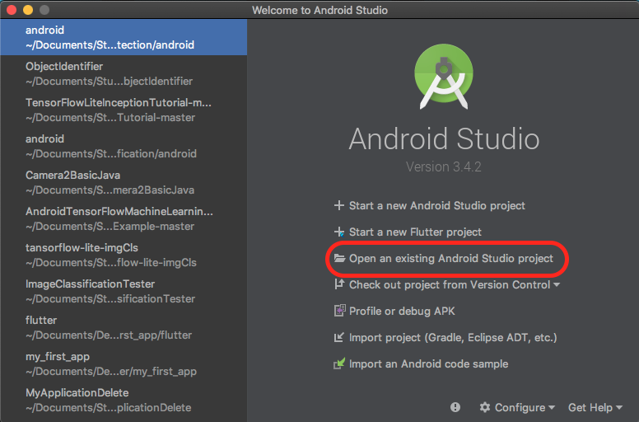

1. Choose ObjectIdentifier project folder and click “Open” to launch Android Studio with this app.

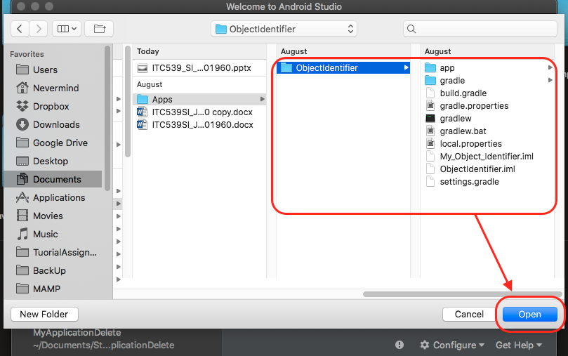

1. If you run into **“Cause: archive is not a ZIP archive” error** while building then please comment out **apply from:'download_model.gradle'** line from **build.gradle** file and use this [link](https://drive.google.com/open?id=1dYUq8YkxPKk07uPyf2NdOILwGlWRSkjA) to download model and label file need for TensorFlow Library. Lastly, just copy the whole assets folder inside this project's assets folder such as, **/src/main/assets/assets/<model_files>**

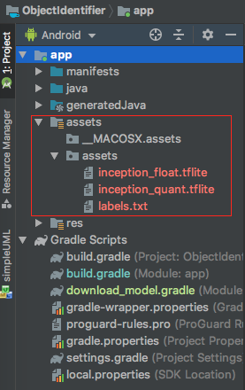

1. Now, click on green play icon which is called “Run app”.

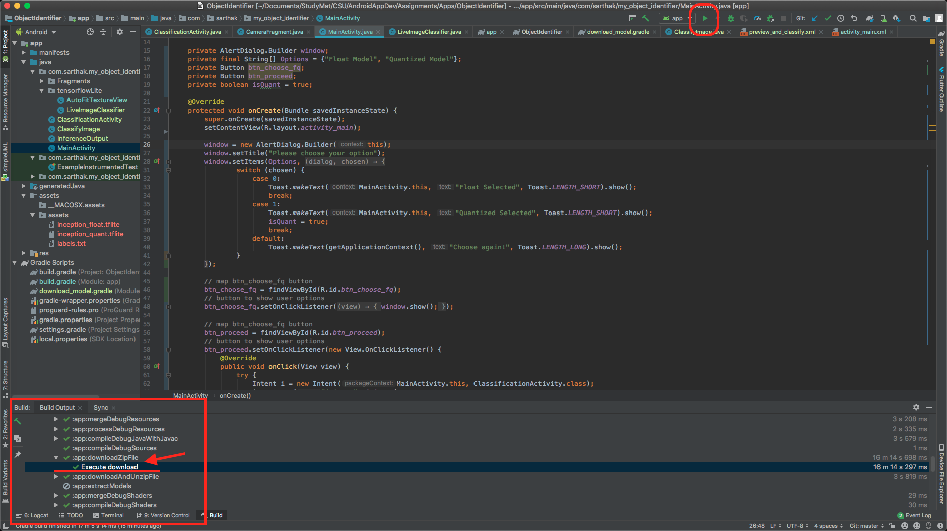

*Please make sure this app is built completely in Android Studio. Specially, “Execute download” process should be completed since it downloads all the Model files through cloud.

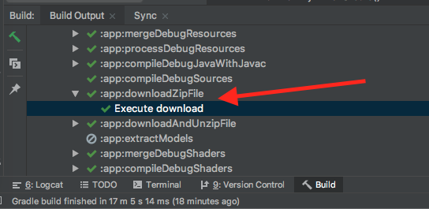

1. Now select one of your emulator device, for instance “Pixel 3 API 28”, or if you have your android device connected, that will show in “Connected Devices” and simply select your own device and click ok “OK” button to launch this app.

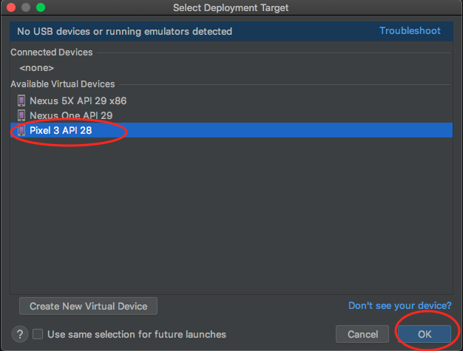

Great! You have successfully install the app on you emulator device or on your own android device.

## APK Installation

1. Copy the provided APK file into your device’s internal or external storage device. This could be done by connecting your device to PC or MAC and simply transferring the APK file.
2. Now, locate the place you copied the APK file into. If you do not find it, please try step 1, once again. If you find it, just tap on the file.
3. This app might be recognized as “unkown app” but we have a solution for this. After step 2, you would see a dialog box saying “For your security your phone is not allowed to install unknown apps from this source”. Also, the dialog box provides Cancel and Settings button.

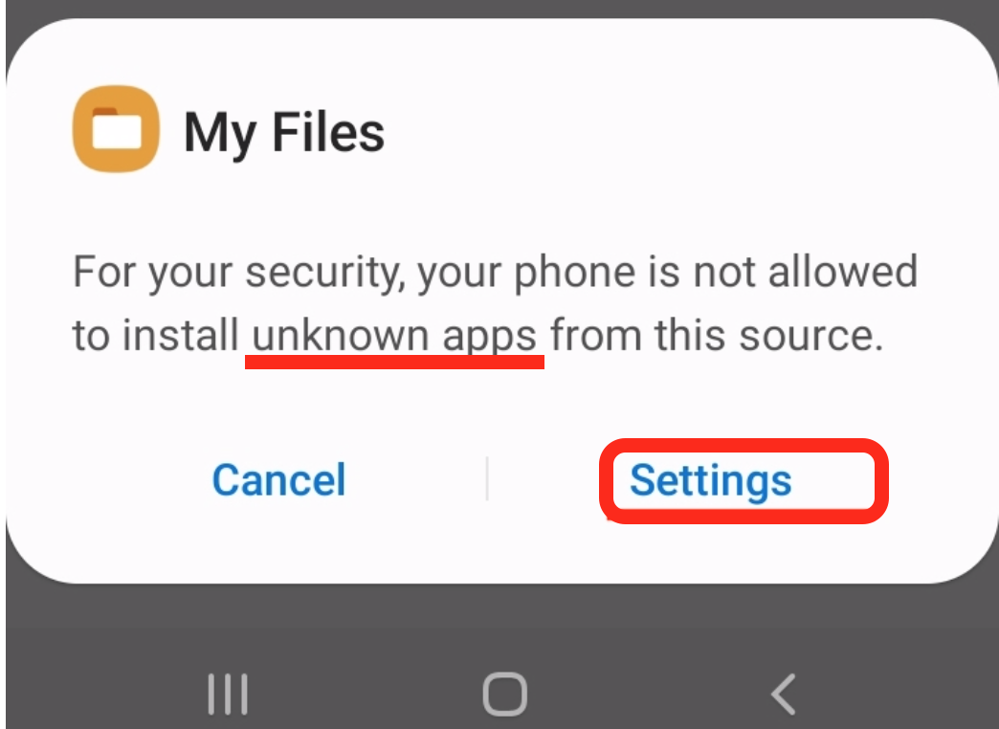

1. Click on Settings button and enable “Allow from this source” option and you’re good to go.

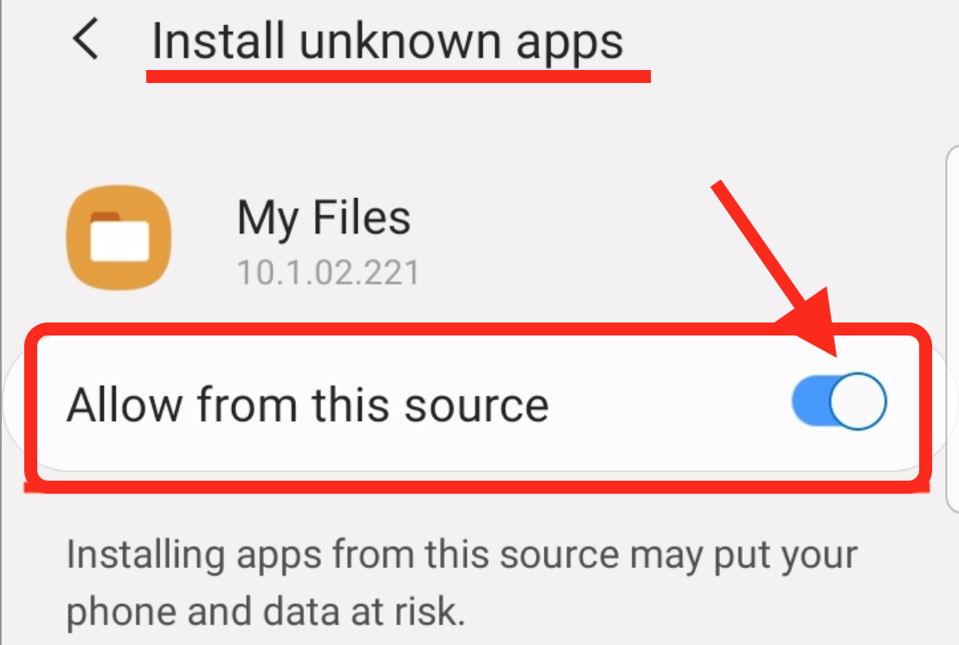

1. Now, tap on Install. And the app will be installed successfully on your device.

# User Manual

After installation of the app, when you open it, you will see this screen first.

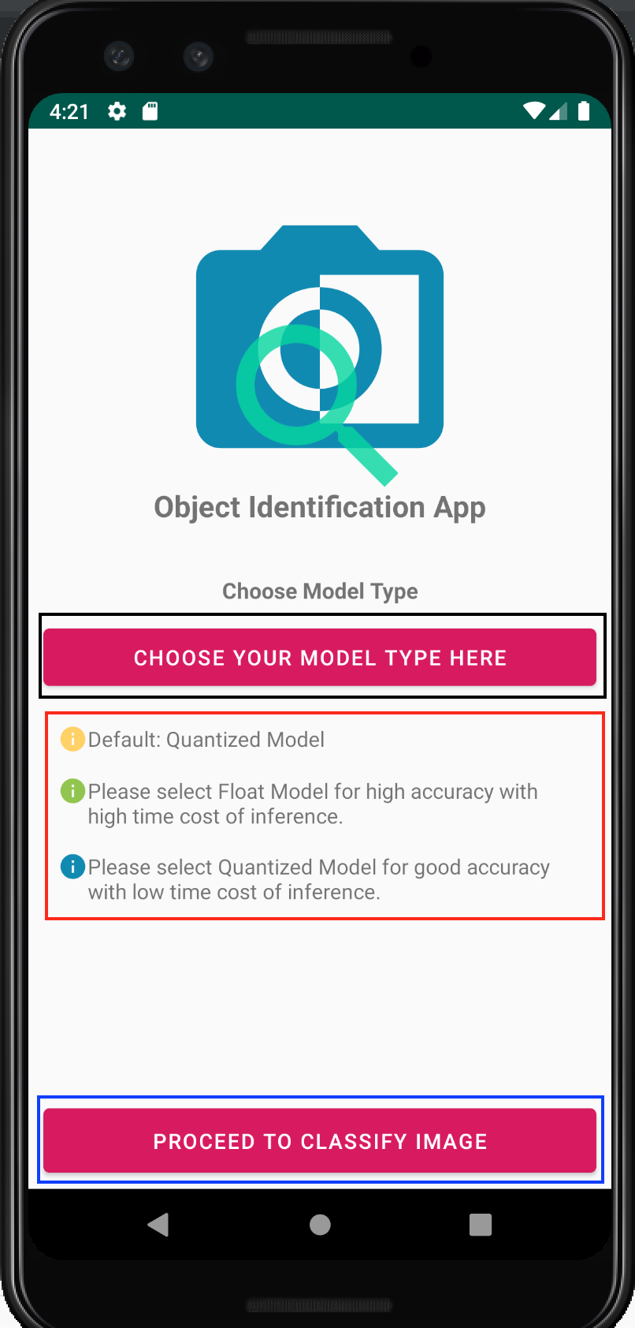

* “**Choose your model type here**”: This button lets you choose types model to classify the image. When you tap on it, you would see such dialog box appear.

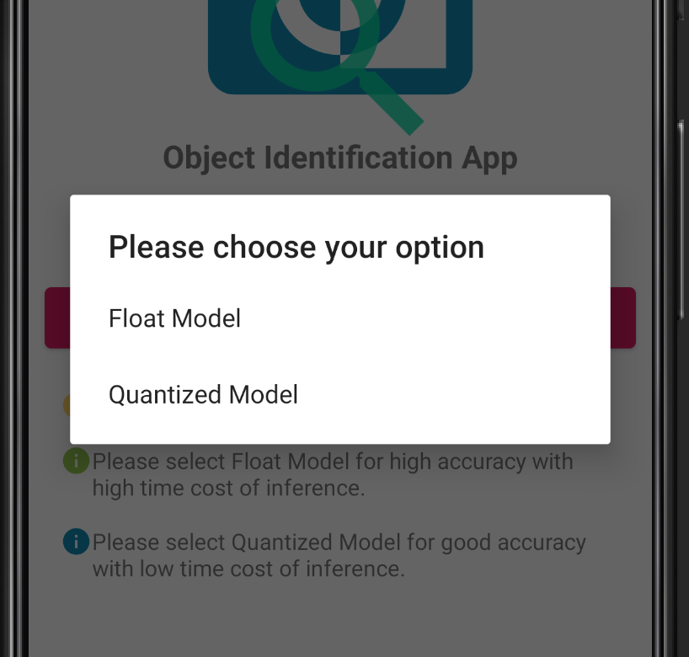

If you select one of those, say, Quantized model, a Toast message will show up for few seconds.

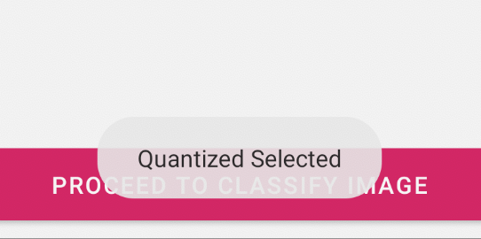

* The information inside red rectangular box tells you about what each model does.
* “**Proceed to classify image**”: This button takes you to the image classification tabs.

## Providing permission to take picture through this app

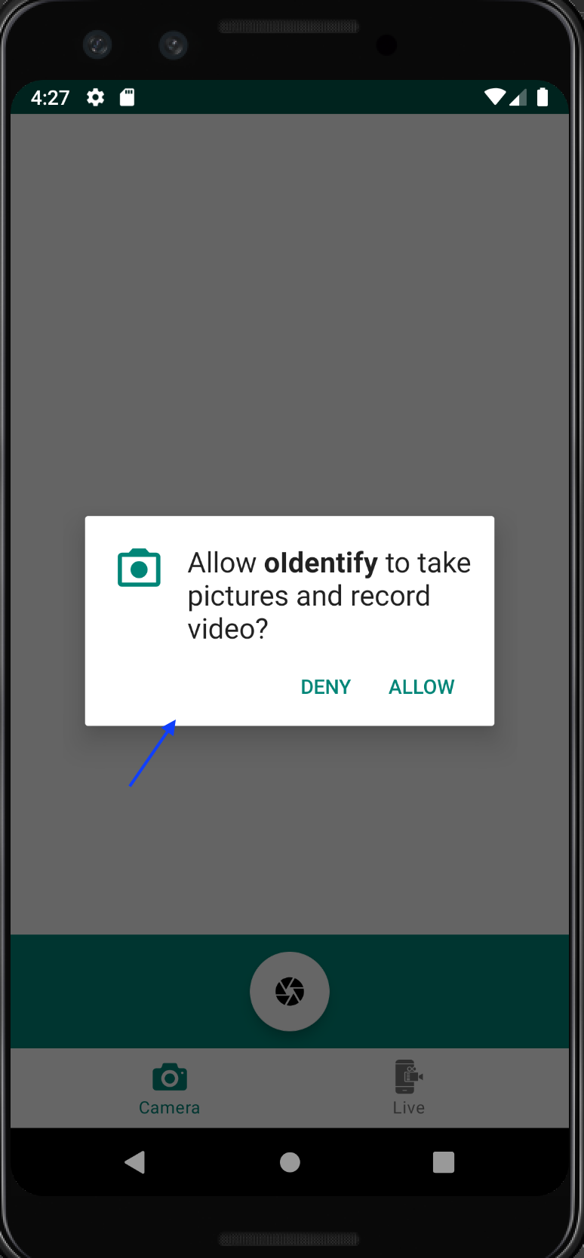 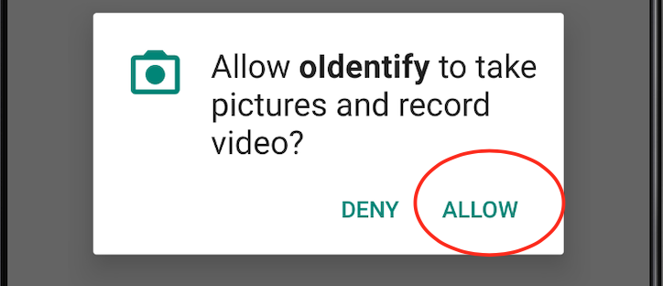

Just tap on “Allow” to grant permission to this app to use camera and take pictures.

## Identifying Image by take picture and classifying it

* In Camera tab, just tap on capture icon to take the photo.

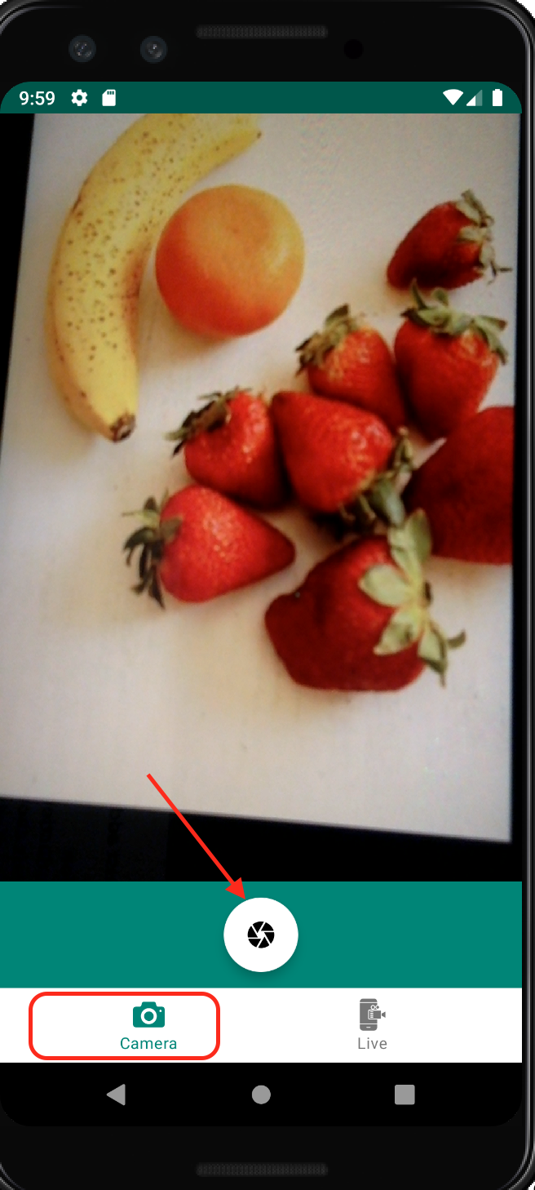

* After taking the photo, app brings another page to classify the image and name it.

“**Classify this image**”: This button starts the classification process in order to identify the captured image.

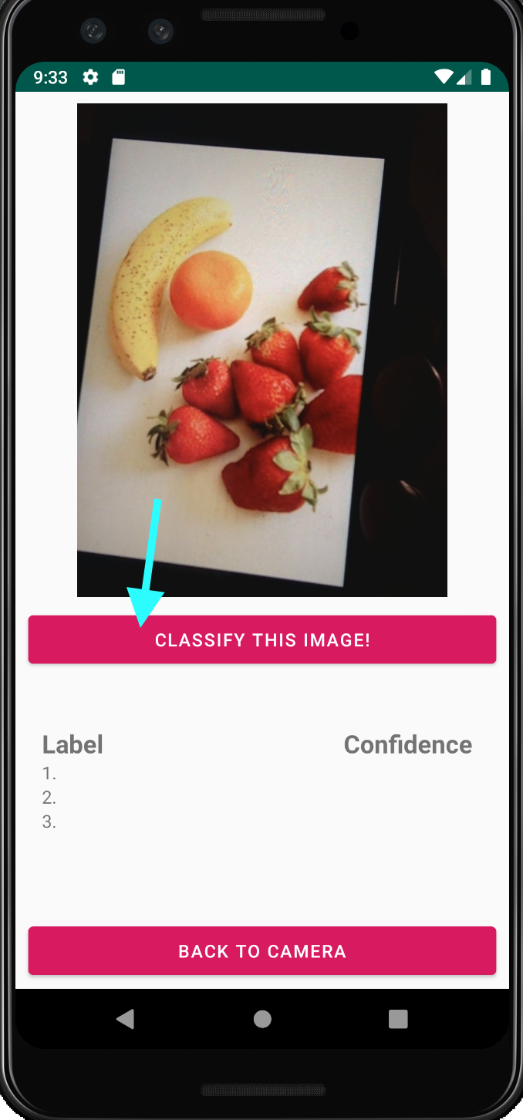

* “**Classifing…**”: This disabled button just updates the process status that it has been classifying the image and might take few second to complete the process.

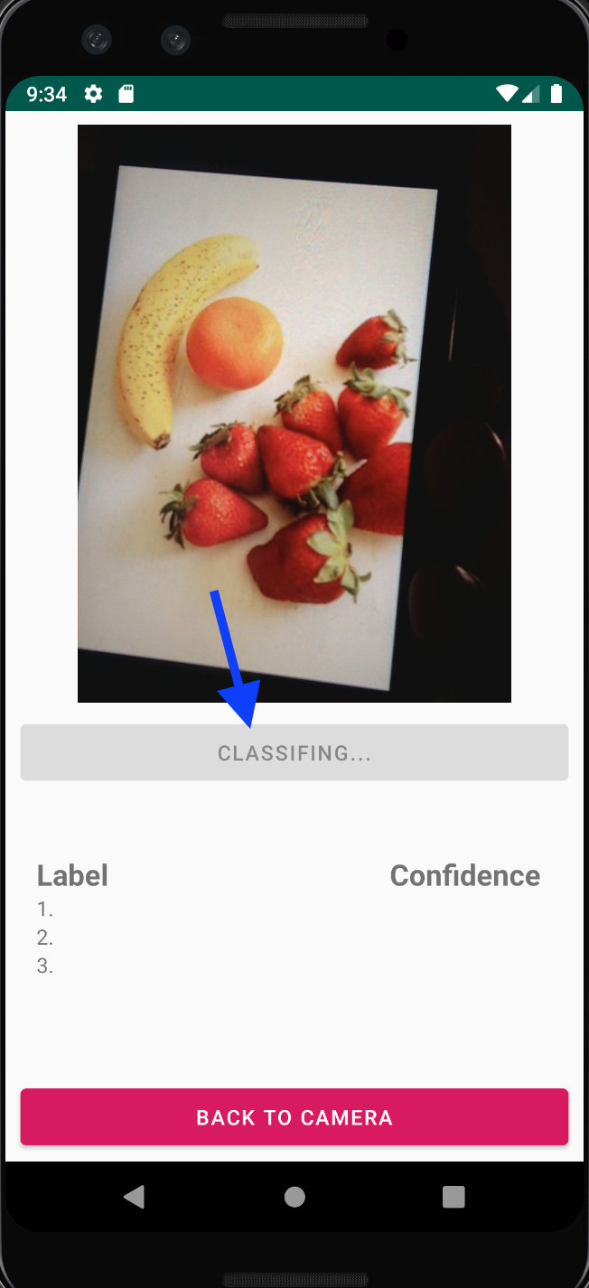

“**Classified**”: This disabled button updates the process status to “Classified”. And, finally we can see the identified name of the multiple object present in the captured image.

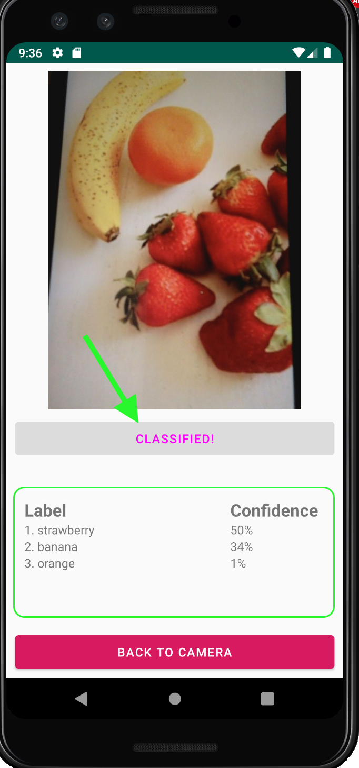

Also, we can see Label and Confidence section in the image. Label shows the names of identified objects and Confidence shows the accuracy rate of that object been identified.

## Object Identification by Live Camera Feeding

Choose the other “Live” tab to identify objects via live camera.

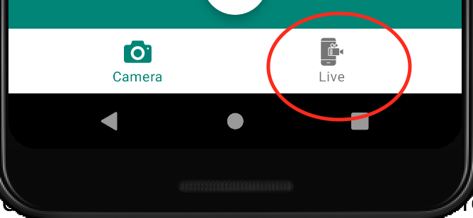

This time we do not have to classify the image or tap on “Classify this image” button anymore. The camera is live and the identification process happens in real-time.

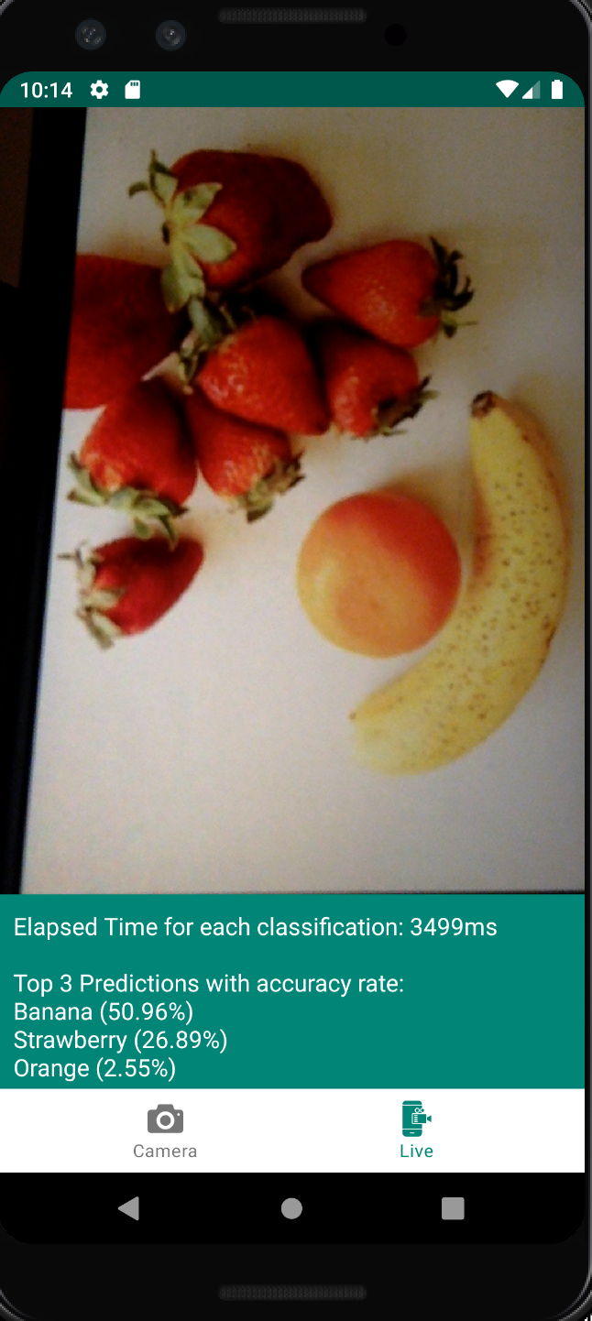

Thank you. Enjoy using this app. ☺